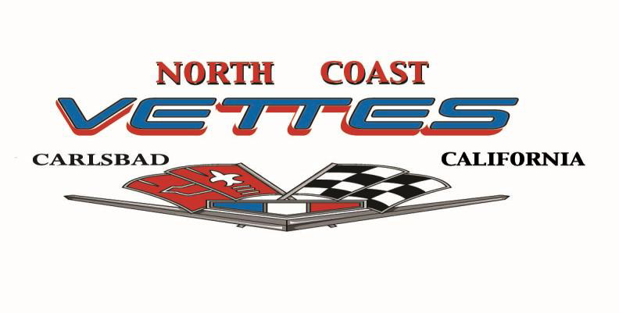
2025 RELEASE AND WAIVER OF LIABILITY, ASSUMPTION OF RISK AND INDEMNITY AGREEMENT

Summarized Statement
This form releases The North Coast Vettes and all Releasees from all liability that arises as a result of my participation in Club Events.

I, the undersigned, hereby release, waive, discharge and covenant not to sue the North Coast Vettes, its officers, representatives, or any and all Club Members, herein referred to as “Releasees” from all liability to the undersigned, his personal representatives, assigns, heirs, and next of kin for any and all loss or damage and any claim or demands therefore on account of injury to the person(s) or property or resulting in death of the undersigned arising out of or related to the event, whether caused by the negligence of the Releasees or otherwise.

I hereby assume full responsibility for any risk or bodily injury, death or property damage arising out of or related to this event whether caused by the negligence of the Releasees or otherwise. I further agree that the car will be operated by a licensed driver, and that the driver will comply with all applicable provisions of the California Motor Vehicle Code. I further warrant that I carry automobile liability insurance on the vehicle, meeting or exceeding all California statutory requirements to be used in this Event and that this insurance is in full force and effect on the date of this Event.

I have read this release and waiver of liability, assumption of risk and indemnity agreement, fully understand its terms, understand that I have given up substantial rights by signing it, and have signed it freely and voluntarily without any inducement, assurance or guarantee being made to me and intend my signature to be a complete and unconditional release of all liability to the greatest extent allowed by law.

Signature Active Member Date Signature Active Member Date
 | ___
_________________________ ___________ | ___________________________ ___________

This form will be completed and retained by the NCV Secretary until replaced by a subsequent form or Member Resignation.

